Jenkins Upstream & Downstream jobs 05/07/23

Step 1: Create a 3 jobs name it as Build, Test and Deploy

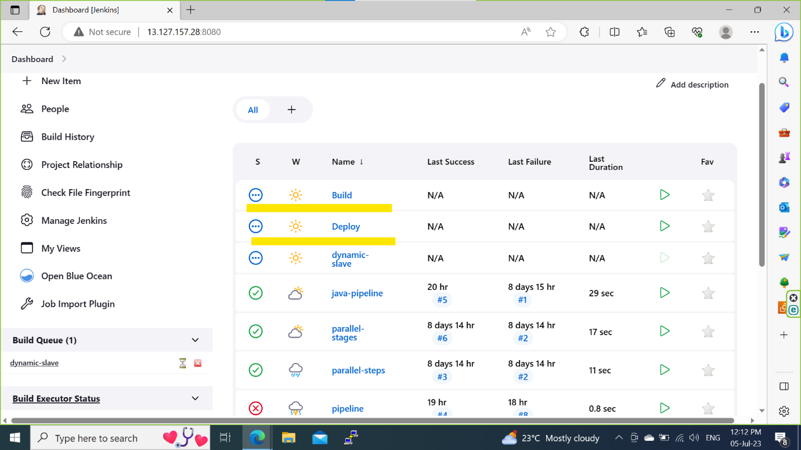

Step 2: write a simple script in execute shell in build steps to execute the job.

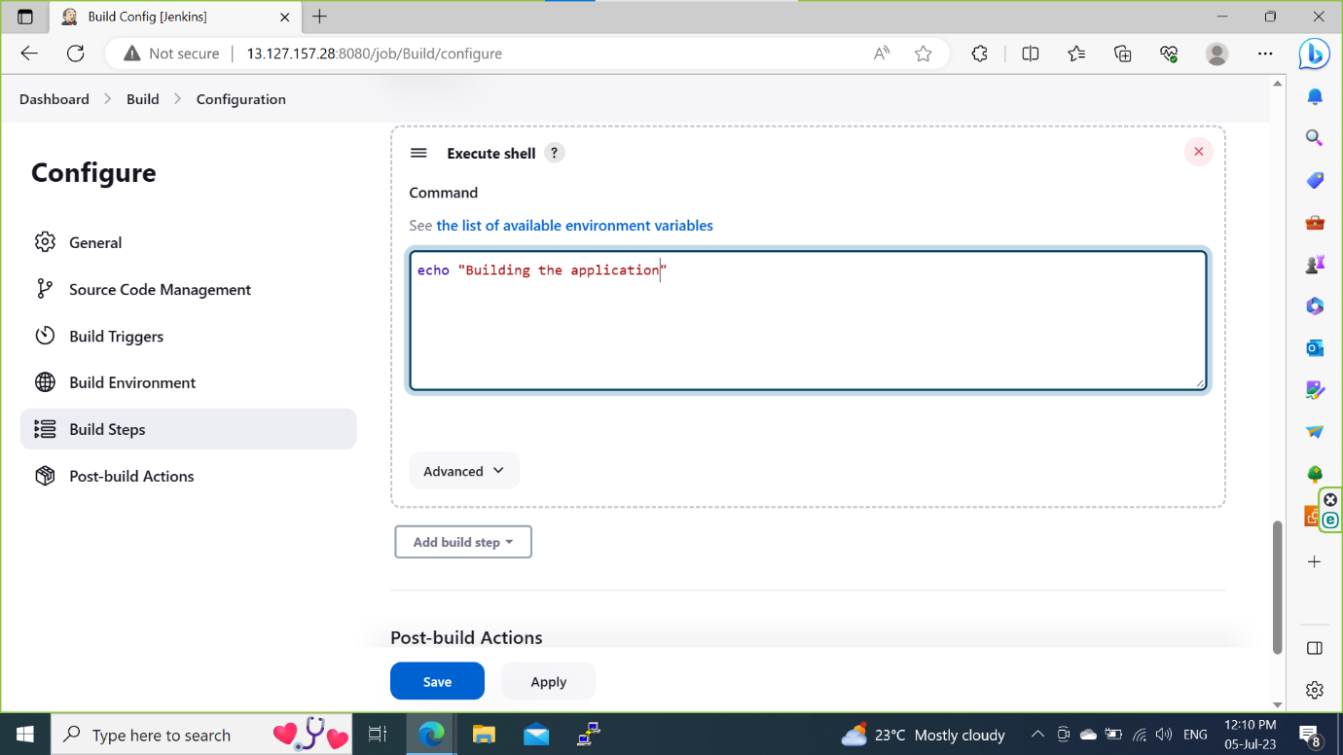

Step 3: In post build actions click on ‘Build other projects’ and mention which project/job will be triggered after completion of current job.

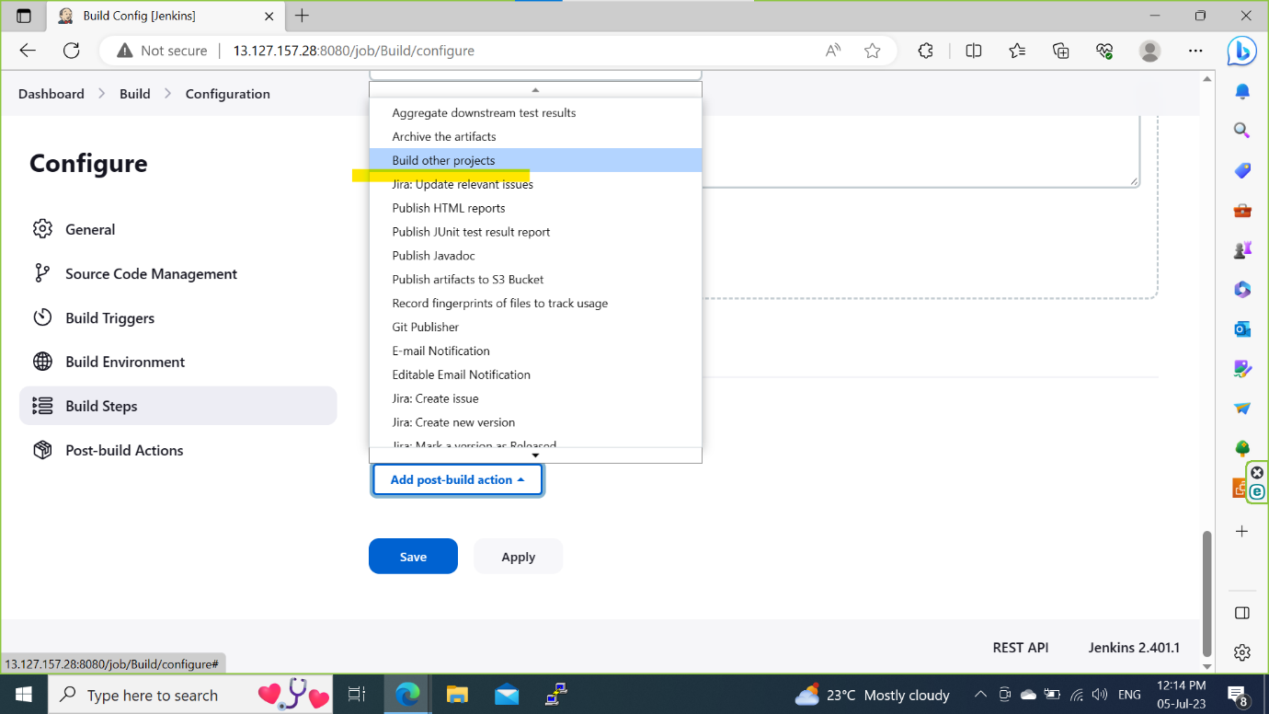

Step 4: Setting up the downstream and upstream

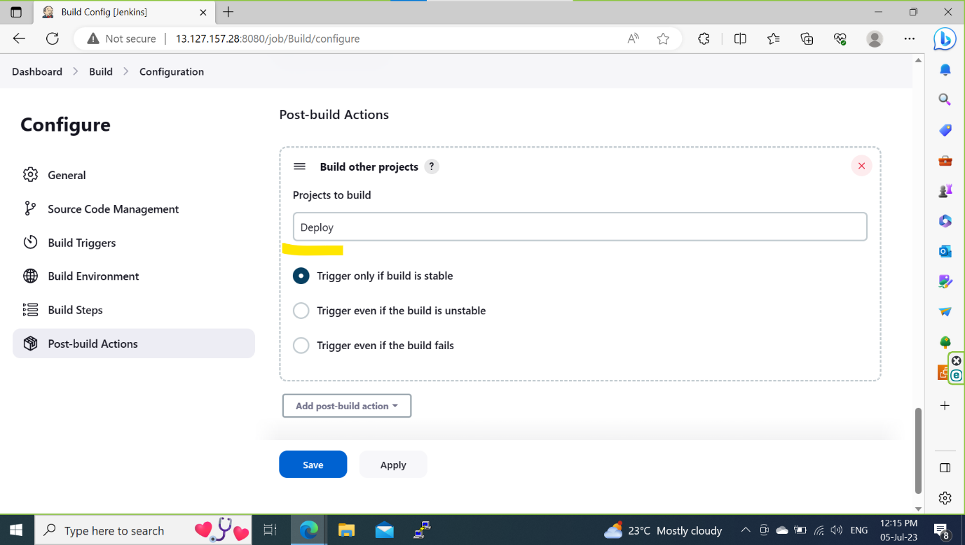

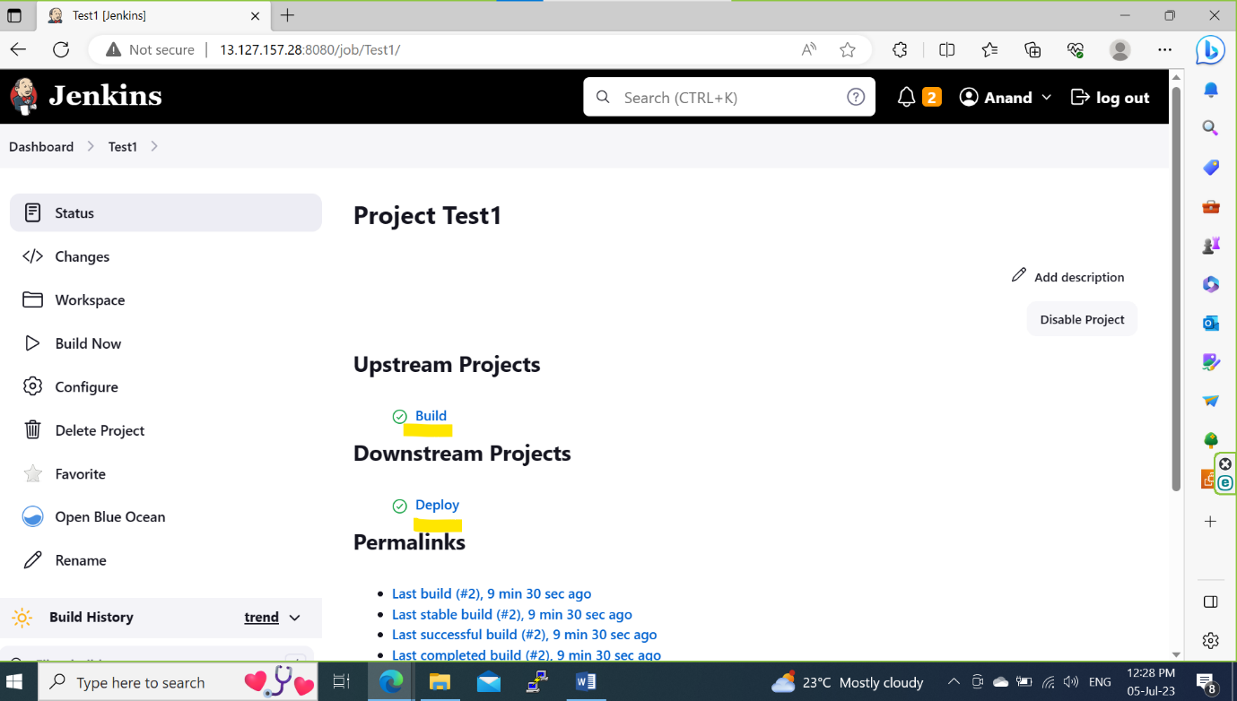

Step 5: Click on build now for ‘Build job’.

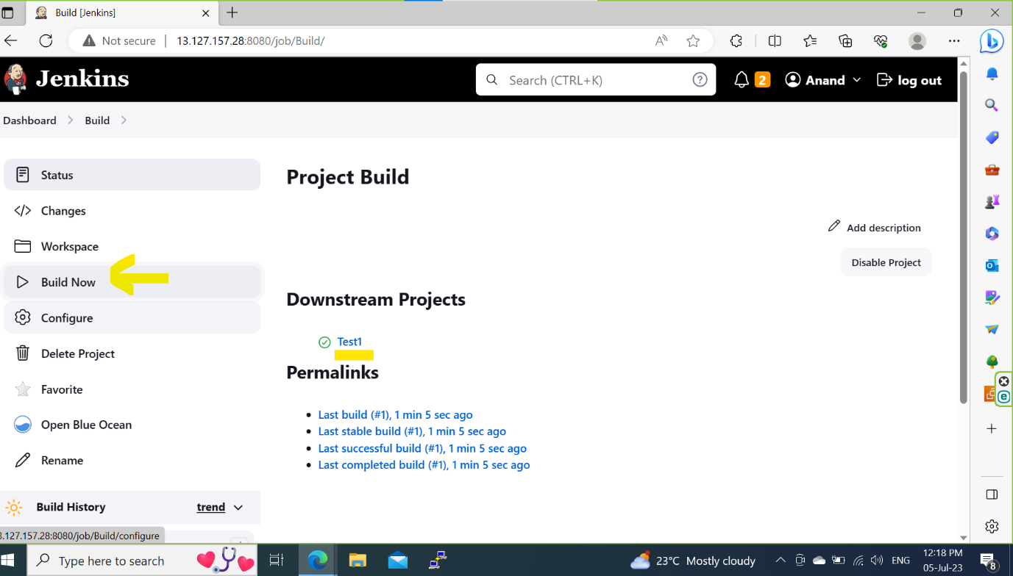

Step 6: Once the Build job done it triggers to the next job based on the configuration.

